ASX Ltd – ASXFY Financial Notes
Started on 7/24/18
General Info
- Business model and operating environment
- ASX is a multi-asset class and integrated exchange group. The Group operates markets for cash equities and derivatives, and provides a full service offering including listings, trading, clearing, settlement, registry, and information and technical services. ASX operates a significant part of the infrastructure that supports Australia’s financial markets.
- The business is conducted through a number of regulated legal entities. ASX holds market operator licences and clearing and settlement licences to undertake its activities. ASX is subject to oversight by the Australian Securities and Investments Commission (ASIC) and the Reserve Bank of Australia (RBA).
- ASX services companies and other issuers that list equity and debt securities on the exchange, as well as a wide range of retail and institutional investors that invest in and trade those securities. Many of ASX’s services are provided through intermediaries including stockbrokers, Australian banks and Australian-based international banks. Clients of these intermediaries include retail and corporate investors, asset managers, custodians and other financial market participants.
- While ASX’s operations are primarily based in Australia, the Group services both domestic and international customers, and some of its services are accessible from offshore.
- Revenue is earned by ASX at various stages of the value chain as discussed below.
- Primary markets capital formation – Listings and Issuer Services
- ASX, through its listing rules and infrastructure, provides a facility for companies to list, raise capital and have their securities publicly traded.
- The Group provides a range of services to issuers of capital, including the generation of security holding statements and other shareholder and sub-register services. Along with the shares of companies, ASX lists debt securities (including government debt securities) and exchange-traded products.
- The Group earns revenue from listed entities for initial listing, annual listing, secondary capital raisings, and for issuer services. The main drivers of revenue in this category include the:
  - number of listed entities and their market value
  - number and value of initial public offerings (IPOs)
  - level of corporate actions, such as secondary capital raisings
  - level of retail trading activity and the resulting number of holding statements.
- ASX faces competition for listings from other exchanges both domestically and internationally. There are also other non-public means of raising capital, such as private equity funds and venture capital, which compete with the ASX primary market.
- Derivatives and OTC Markets
- ASX offers exchange-traded derivatives, including the trading and clearing of futures and options on futures on interest rate, equity index, agricultural and energy contracts, as well as exchange-traded options over individual securities. The number of contracts traded is the primary revenue driver. ASX provides central counterparty clearing (CCP) of these exchange-traded derivatives as well as clearing of over-the-counter (OTC) derivatives through a licensed clearing subsidiary, ASX Clear (Futures). This entity provides risk management services supported by clearing participant collateral and funds provided by both ASX and participants, which are available in the event participants fail to meet their obligations. Competition comes from offshore exchanges and OTC products. Clearing of futures and options occurs exclusively in Australia by ASX, while clearing of OTC derivatives may be undertaken by certain foreign- domiciled clearing entities.
- Austraclear
- Austraclear provides settlement, depository and registry services for debt securities and cash transactions. ASX’s model for debt securities settles transactions on a trade-by-trade basis, which provides for certainty of settlement. The number of transactions is the main revenue driver.
- Depository services are provided through the Austraclear Central Securities Depository (CSD). These securities consist of fixed income securities, including government bonds. Settlement of transactions on these securities occurs through real-time gross settlement (RTGS). The value of securities held is the main revenue driver.
- Registry services are provided whereby Austraclear facilitates security registration and the subsequent cash transfers associated with the terms of the individual securities. The main drivers of registry revenue are the number and value of securities held in the registry.
- The ASX Collateral Service allows customers of ASX to utilise collateral held in Austraclear to meet obligations to other customers or to ASX’s clearing subsidiaries.
- Secondary markets – Trading Services
- Trading Services comprises the trading of securities in the cash market as well as the information and technical services offered by ASX.
- Cash market comprises the trading of cash market securities and includes equity (shares), warrants, exchange-traded funds and listed debt securities. The value of turnover transacted on the ASX market is the primary revenue driver. There is competition in trading from another equity market operator and off-market trading facilities, which are often referred to as ‘broker dark pools’.
- ASX provides information and technical services to its clients to support their secondary market activities. Information services include the provision of real-time market data for the cash and derivative markets, company news, and index and other reference data. The main revenue driver is the number of end-users accessing real-time market data and customer enterprise agreements for the provision of data.
- Technical services consists of four main categories of services to facilitate market connectivity and access to ASX and third-party services by customers. These are:
  - liquidity access via ASX platforms
  - community and connectivity services including a secure low latency communication network via ASX Net
  - application services including terminals to access ASX platforms
  - hosting of customer infrastructure within the ASX Australian Liquidity Centre (ALC).
- Revenue drivers for each category consist of the volume of services used by customers, such as the number of connections to ASX markets or the number of cabinets hosted in the ALC.
- Equity Post-Trade Services
- ASX’s clearing and settlement infrastructure provides risk management services to financial market participants and investors. ASX’s post-trade operations are backed by significant Australian-based capital and collateral, and are overseen by Australia’s regulators. Clearing and settlement of cash markets is undertaken by ASX for the entire Australian marketplace.
- Cash market clearing
- ASX provides CCP services to the cash market through a licensed subsidiary, ASX Clear. As a CCP, the clearing subsidiary becomes the central counterparty to every trade and assumes the credit risk of each ASX clearing participant. The CCP supports these risk management activities with collateral lodged by clearing participants and significant ASX capital available in the event of participant failure to meet their obligations. In certain circumstances, ASX may also call further funds from participants. The main revenue driver is the value of equity securities centrally cleared.
- Cash market settlement
- ASX’s settlement services help reduce counterparty and systemic risk, and provide transaction efficiency and certainty for end-investors. Settlement occurs on a delivery-versus-payment (DvP) basis and involves the exchange of cash for physical delivery of securities.
- Cash market settlement is conducted through the Clearing House Electronic Sub-register System (CHESS). This system registers the title (ownership) of shares. ASX’s model for cash market settlement maximises efficiency through the netting of settlement obligations in each individual security and the netting of all payment obligations, while minimising the risk of settlement failure. The main driver of settlement revenue is the number of settlement messages.
- 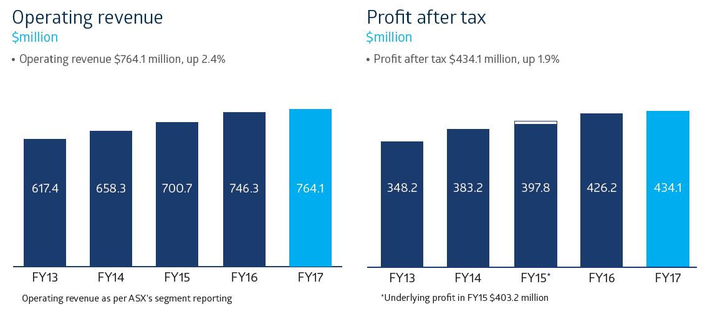
- 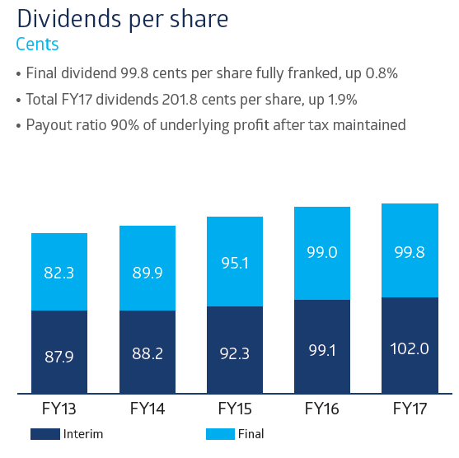
- We upgraded the trading platform for our largest business, raised the profile of ASX’s listings and clearing franchise internationally, and marked the 30th anniversary of ASX’s formation, when Australia’s six state-based stock exchanges merged to establish one national market.
- The benefits of the 1987 amalgamation still resonate, with ASX’s global scale, connectivity and reputation attracting increasing numbers of companies, traders and investors from home and abroad. It paved the way for ASX’s demutualisation and listing in 1998, and the merger with the Sydney Futures Exchange in 2006, which brought equities and futures together to create one of the world’s first multi-asset class, integrated exchange groups. The innovation we demonstrated three decades ago continues today as we seek better ways to service our customers and strengthen the resilience and competitiveness of Australia’s financial markets.
- ASX continued its solid financial performance in financial year 2017 (FY17), with revenue growth in most major areas of the business. The exception was the Listings and Issuer Services business, which was flat compared to FY16 and characterised by less capital raised but a greater number of new listings, the most in six years. ASX’s performance was driven by pockets of volatility in futures and equity markets, and strong progress on key initiatives such as Centre Point and OTC Clearing.
- ASX continues to invest in the infrastructure that positions Australia’s financial markets for the future. Expenses rose 6.0% to $180.9 million and capital expenditure was $50.3 million, both in line with market guidance. The spending relates to continued infrastructure upgrades as well as ASX initiatives such as the new futures trading system, development of the Bank Bill Swap (BBSW) platform and progress with distributed ledger technology (DLT) as a potential solution to replace CHESS
- ASX has been exploring DLT (commonly known as blockchain) as a possible replacement for CHESS. DLT has the potential to create a ‘single source of truth’ for all transactions that cannot be altered and which can be distributed to those who are permissioned to access it. We are developing an enterprise-grade DLT system with our partner Digital Asset Holdings. This will enable us to determine its suitability as a replacement for CHESS. We are on track to make an assessment on its suitability towards the end of this calendar year. ASX believes there is a real opportunity to simplify how our marketplace works and unlock a new era of efficiency and innovation. By working with our customers, we can develop the solution that best positions Australia’s market for the future.
- ASX clearing and settlement subsidiaries
- ASX has four subsidiary companies that hold CS licences to operate clearing and settlement facilities, and two intermediate holding companies. The CS boards focus on risk management and oversight of the operations of the CS subsidiaries.
- The responsibilities of these boards include the management of clearing and settlement risk, and compliance with the Financial Stability Standards determined by the Reserve Bank of Australia (RBA).
- The CS boards’ charter sets out further details regarding their functions and governance.
- ASX Clear and ASX Settlement are the sole providers of clearing and settlement arrangements for Australia’s cash equities market. The boards of ASX Clear and ASX Settlement are comprised of six directors. Each has three directors who do not sit on the ASX Limited Board. These three directors can form a quorum and do meet separately, constituted as the board of ASX Clear and ASX Settlement, to determine matters that require consideration of commercially sensitive information if another market operator or listing venue is obtaining services from, or access to, ASX’s CS facilities. These boards also oversee Management’s handling of commercially sensitive information, provision of services or access relating to other market operators and listing venues. ASX Limited directors do not attend or receive copies of papers or minutes for such meetings. Management attendance is limited to employees given permission by the relevant market operator or listing venue.
- Derivatives and OTC Markets
- In March 2017, ASX successfully implemented a new futures trading system, replacing the platform that had been in place, with periodic updates, since the late 1990s.
- The new system is contemporary and uses global standard protocols. It provides customers with richer functionality, improved performance and reduced development and maintenance costs. It also offers a new way of working with our customers, with functionality allowing ASX to diagnose and discuss issues proactively with customers. The smooth go-live was helped by the extensive development and industry-wide testing program undertaken by ASX in close collaboration with customers.
- Remuneration philosophy
- ASX’s remuneration rewards behaviours and results that contribute toward the delivery of the ASX strategy. The framework is based on the following key principles:
- link rewards to the achievement of the strategy and the creation of shareholder value
- 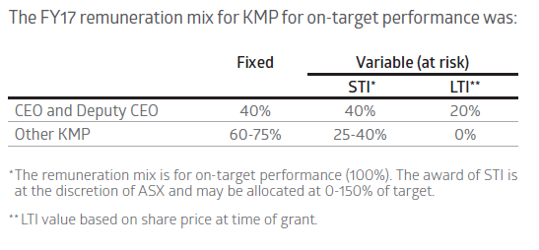
- 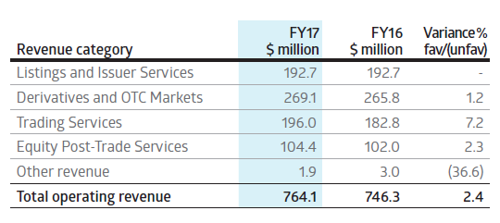
- Annual listing revenue – up 5.5% to $79.3 million. There were 2,239 entities listed on ASX at 30 June 2017 (30 June 2016: 2,204). Increases in market capitalisation combined with fee changes were the main drivers supporting the increase in revenue.
- ••Initial listing revenue – down 13.8% to $16.0 million. While there were 152 IPOs compared to 124 in the prior year, IPO capital raised was $14.7 billion, down from $23.6 billion. In FY17, listings were from a range of industry sectors, with 23 initial listings from the technology sector and 30 foreign initial listings.
- ••Secondary capital raisings revenue – up 3.1% to $46.5 million. An increase in the number of secondary capital raisings combined with fee changes were the main drivers supporting the increase in revenue. The total level of secondary capital raised was 24.9% lower than the pcp, reflecting smaller capital raisings due to the absence of the large bank capital raisings that occurred in the pcp.
- ••Issuer services revenue – down 2.0% to $42.4 million. The decrease in revenue resulted primarily from a decline in the number of CHESS holding statements, which were down 2.8%.
- Derivatives and OTC Markets – $269.1 million, up 1.2%
- The revenue increase resulted from:
- Futures and OTC – up 1.6% to $197.4 million. The growth in revenue was due to a 4.1% increase in volumes, partly offset by higher rebates. The value cleared through the OTC Clearing service increased significantly to $5.2 trillion compared to $2.7 trillion in the pcp.
- Equity options – down 6.4% to $21.7 million. While the total volume of contracts traded was up 2.2%, the decrease in revenue was due to a change in the mix of products and users. Single stock option volumes were up 5.2% while index option volumes were down 18.6%.
- •Austraclear – up 3.4% to $50.0 million. The increase in revenue was primarily due to higher average balances in the depository and increased transactions. The ASX Collateral service also grew with the value of assets increasing 237% to $16.2 billion at 30 June 2017 compared to $4.8 billion in the pcp.
- Trading Services – $196.0 million, up 7.2%
- The following table depicts the growth in ASX on-market value traded over the past five years.
- Cash Market Trading – up 13.8% to $46.3 million
- The increase in revenue resulted from:
- Higher on-market trading of $4.3 billion per day, up 2.3%. ASX’s share of on-market trading averaged 87.5% in FY17, compared to 88.7% in FY16.
- Increased trading through Centre Point and the auction service, both of which attract higher fees. In FY17, Centre Point value traded was $107.0 billion, representing 9.9% of ASX on-market value traded. Trading through the auction service represented 22.0% of on-market value traded. Together these accounted for 49.5% of ASX trading revenue.
- The participant trading rebate scheme was discontinued from 1 July 2016; $2.2 million was rebated in the pcp.
- Information Services – up 3.0% to $82.5 million
- The increase in revenue resulted from:
- Revenue from the BBSW interest rate benchmark which ASX commenced providing in January 2017.
- Fee changes to certain data services.
- Technical Services – up 8.4% to $67.2 million
- The increase in revenue resulted from:
- Liquidity access – up 5.8% to $33.1 million. Over the year, the total number of ALC service connections increased from 819 to 871.
- Community and connectivity – up 13.3% to $19.6 million, attributed to the growth in users of ASX technical services provided at the ALC and through its data networks.
- Application services – down 7.5% to $4.9 million. The revenue was impacted by a lower number of installation charges in the ALC.
- Hosting – up 18.4% to $9.6 million. In FY17, the number of customer cabinets hosted in the ALC increased from 231 to 285 at 30 June 2017.
- Equity Post-Trade Services – $104.4 million, up 2.3%Cash market clearing – down 1.6% to $53.3 million The decrease in revenue resulted from:
- The daily average on-market value cleared increased 4.0% to $4.6 billion reflecting the increase in trading across all venues in Australia.
- ASX reducing clearing fees by 10% from 1 July 2016.
- No clearing revenue sharing rebate paid, compared to $3.2 million in the pcp.
- Cash market settlement – up 6.8% to $51.1 million The increase in revenue resulted from:
- Increased trading activity levels led to a 2.9% increase in the dominant settlement messages compared to FY16.
- The settlement revenue sharing rebate was $1.1 million compared to $2.1 million in the pcp.
- 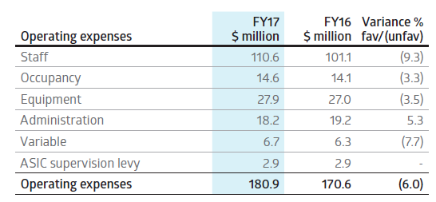
Things of Note
- ASX is privileged to operate in an environment underpinned by Australia’s strong macro-economic drivers. These include one of the world’s largest savings pools, highly regarded regulatory framework and more than 25 years of uninterrupted economic growth. Alongside this, Australia continues to have one of the world’s highest rates of share ownership, with the latest ASX Australian Investor Study (published in May 2017) showing that 37% of Australian adults, or 6.9 million people, hold investments that are available through a financial exchange.
- 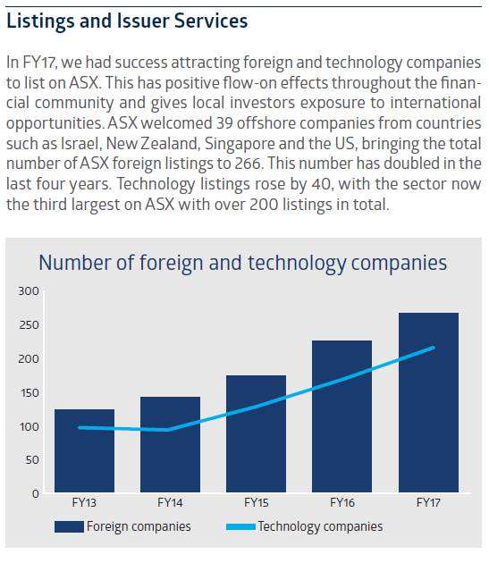
- ASX has developed a ‘sweet spot’ for listing companies in the $50-500 million market capitalisation range. The depth of our market’s liquidity, our contemporary rules and guidance, and the quality of our corporate governance standards are among ASX's advantages. The new admission criteria that ASX introduced in December 2016 have lifted the bar for entry to the ASX market, while maintaining a pathway for companies to list and access capital across their lifecycle.
- The expansion of ASX’s listings franchise in FY17 included growth in exchange-traded products (ETPs) such as ETFs – especially those offering international exposure, which now represent 42% of total ETP funds under management. ETPs have grown over the last five years from 84 products valued at $5.2 billion to more than 213 products valued at over $29.5 billion today.
- In FY17, ASX received regulatory approval to expand the range of investment products retail clients can apply for and redeem through the mFund Settlement Service. The mFund service provides faster and more convenient access to unlisted managed funds. The ability to offer a wider range of funds makes the service more attractive to brokers, advisers and their clients, including those in the growing SMSF sector. The level of funds under management within mFund doubled over the course of the year to more than $370 million.
- ASX also expanded the operating hours of our OTC Clearing business to clear interest rate swaps 24 hours a day. Value cleared in this service was up 88% in FY17 with a record $1,542 billion notional value cleared in the June quarter. We expect this to grow further when we roll out the service to clients of dealers (in addition to the existing dealer-to-dealer service) towards the end of 2017.
- Over the past five years, activity on ASX from offshore futures investors and traders has grown steadily. Global access to ASX markets has expanded in recent years via connections to financial hubs in Chicago, London, Singapore and Hong Kong. ASX’s overnight futures trading session, open from 5pm to 7am AEST, now accounts for 31% of all futures trading activity, up from 22% in FY12.
- 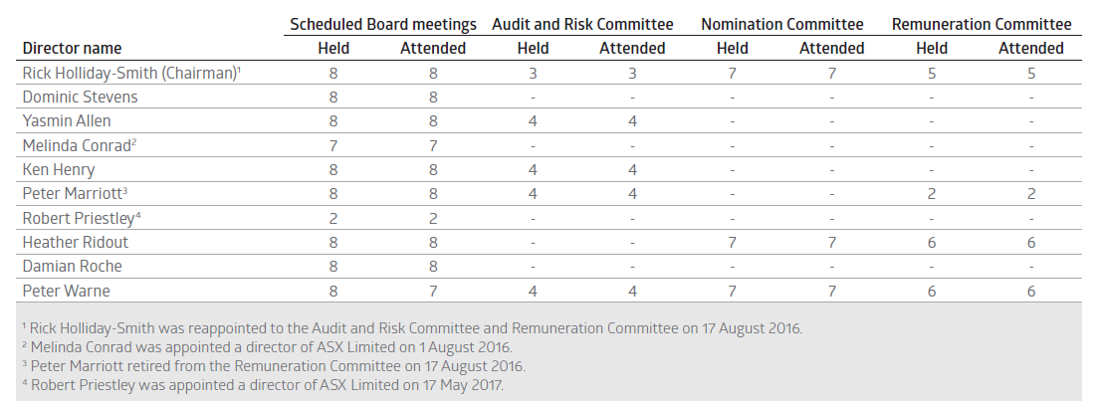
- Director shareholding policy and remuneration
- Board policy is that non-executive directors should accumulate at least 5,000 ASX shares (12,000 for the Chairman) within three years of their appointment. All directors with a tenure of more than three years meet this guideline. Directors with less than three years tenure are progressing towards achieving this guideline.
- Trading by ASX Group directors and employees
- ASX’s Group Dealing Rules restrict dealing in securities by ASX directors and employees. These were reviewed in FY17. Derivatives and hedging arrangements for unvested ASX securities, or vested ASX securities subject to holding locks, are prohibited.
- Payments to political parties
- ASX actively engages with government and political decision-makers about its role, the investments it is making to build world-class infrastructure, and the dynamic and globally competitive market environment in which it operates.
- ASX has a responsibility to Australia’s financial markets and its shareholders, customers and staff to articulate the opportunities and challenges facing its business, communicate its position on relevant public policy issues, and contribute to well-informed decision-making by government.
- During FY17, ASX paid $100,000 in membership fees to each of the Liberal Party Australian Business Network and the Federal Labor Business Forum. ASX’s membership of these business networks provides an opportunity to engage with a wide cross-section of policy and business decision-makers. No other payments to political parties were made during FY17.
- Environment, social and governance
- 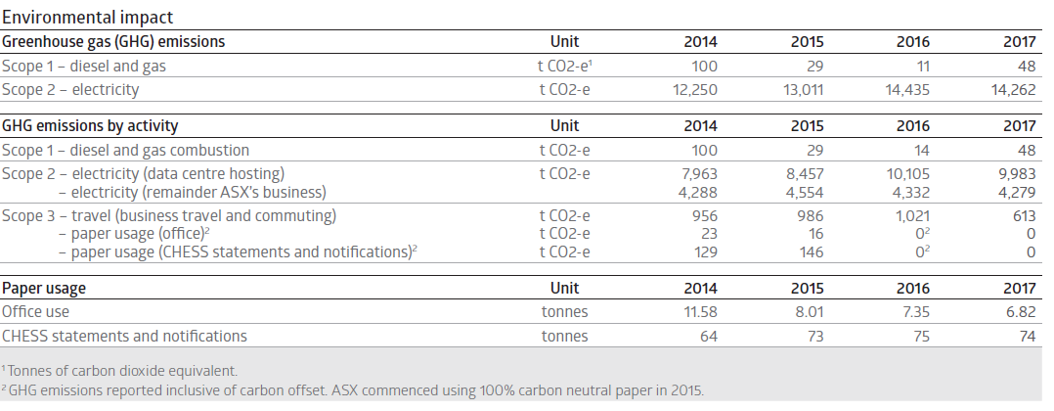
- Fixed remuneration
- Fixed remuneration comprises cash salary, superannuation and other salary sacrificed benefits.
- Fixed remuneration is reviewed on an annual basis against comparable market data. ASX market positioning is the median to upper quartile, depending on individual performance. Increases are not automatic and are subject to a minimum level of individual performance.
- 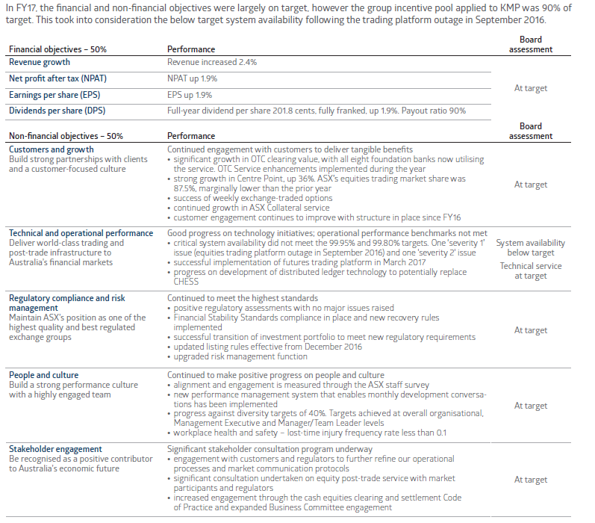
- The purpose of the LTI plan is to recognise performance and behaviours that deliver substantial long-term shareholder value.
- Only the CEO and the Deputy CEO participate in ASX’s LTI plan. ASX will submit Mr Stevens' FY18 LTI grant for shareholder approval at the 2017 AGM.
- The LTI is a grant of performance rights over ASX ordinary shares, which will vest if ASX achieves performance hurdles determined by the Board.
- ASX’s LTI has a four-year performance period. The number of performance rights allocated is based on the volume weighted average price of ASX shares (face value) on the 10 business days preceding the grant date. No dividends are paid on the performance rights. There is no retesting. Half of the performance rights have an EPS and half have a TSR performance condition.
- 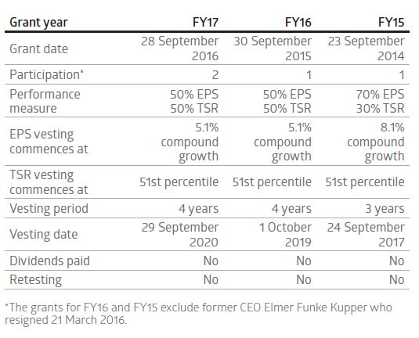
- 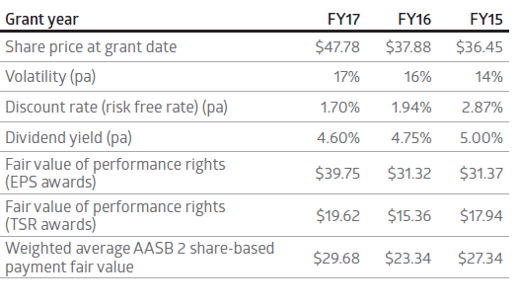
- The Clawback Policy permits the Board to clawback some or all of an executive’s proposed performance-based remuneration if the Board considers that such remuneration would be an ‘inappropriate benefit’. This includes any STI or LTI award and other performance-based component of remuneration that has not yet been paid or vested without restrictions to an executive. The Board has absolute discretion to determine what constitutes an ‘inappropriate benefit’ and how to apply the clawback, subject to compliance with the law and the conditions set out in the policy. This discretion can be applied at any time.
- 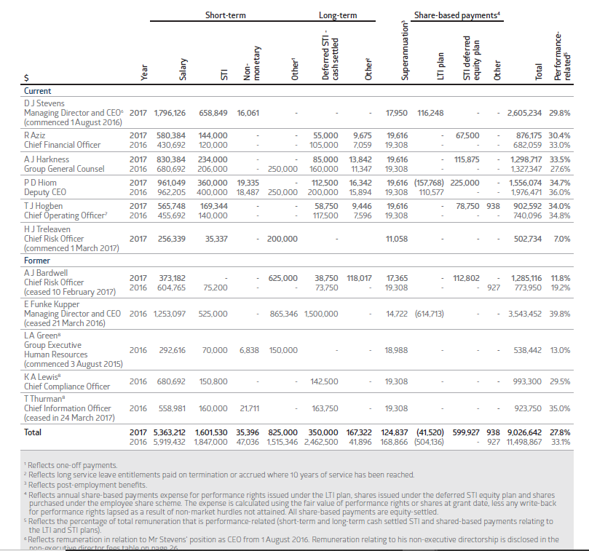
- 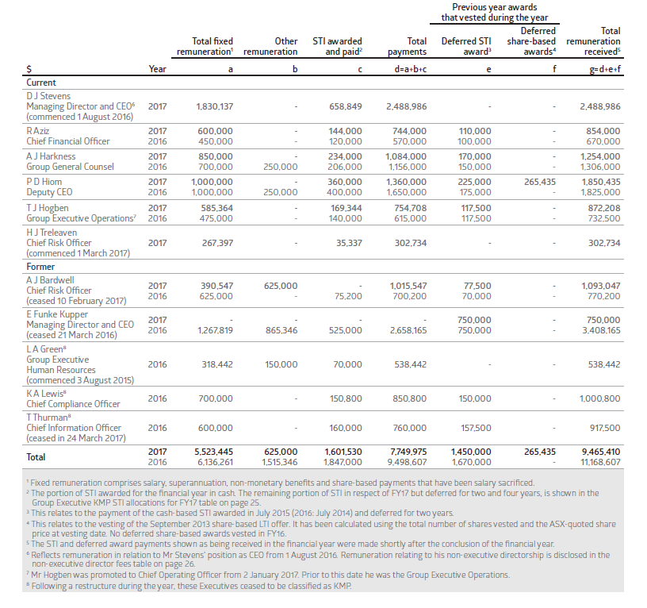
- 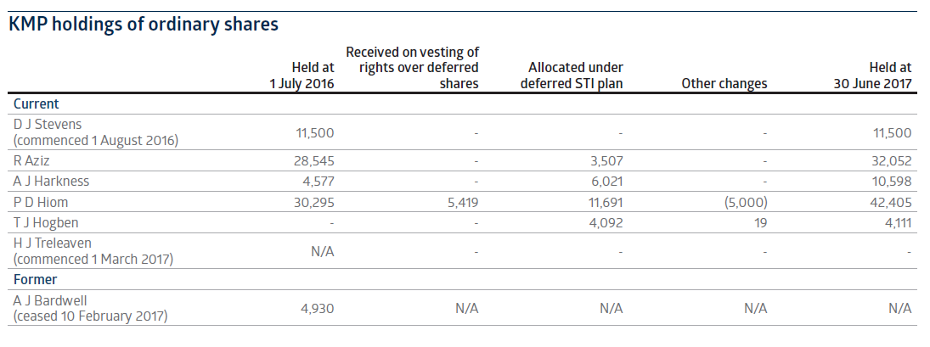
- 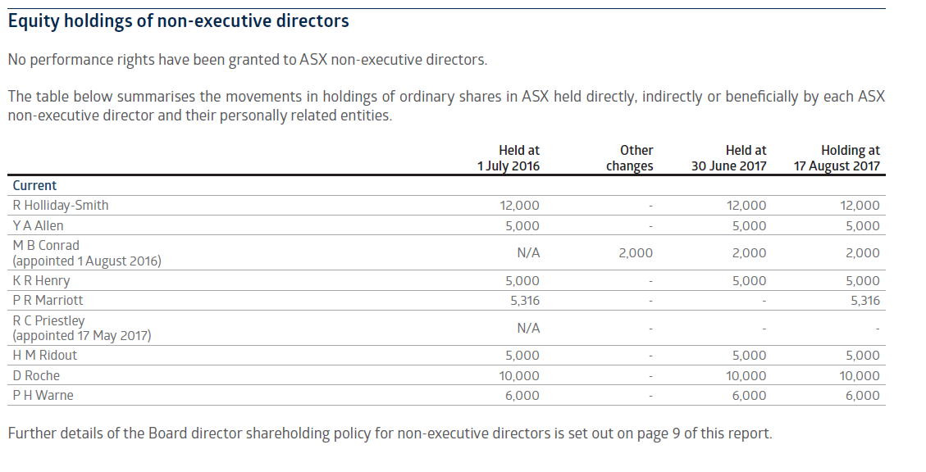
- Capital expenditure
- The Group invested $50.3 million in capital expenditure during the year, compared to $50.2 million in FY16. Expenditure included the development of a number of key projects, such as distributed ledger technology for the potential CHESS replacement as well as implementation of a new futures trading platform.
- 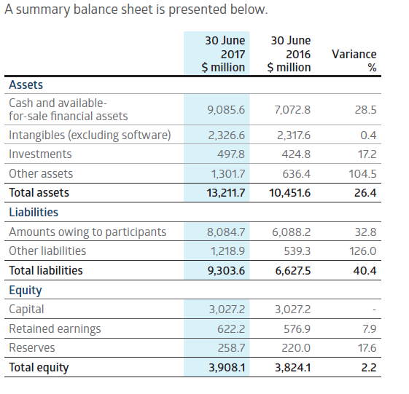
- Investments – up $73.0 million or 17.2%
- Investments reflect ASX’s 18.8% shareholding in IRESS Limited, a listed entity providing financial market and wealth management technology solutions; a 49% shareholding in Yieldbroker Pty Limited, an unlisted entity operating licensed electronic markets for trading Australian and New Zealand debt securities; and an 8.5% shareholding in Digital Asset Holdings LLC (DAH), an unlisted US domiciled technology entity. The growth reflects ASX's purchase of additional IRESS shares and the increase in their share price.
- Amounts owing to participants – up $1,996.5 million or 32.8%
- As part of its clearing operations, the Group holds a significant amount of collateral lodged by participants to cover cash market and derivatives exposures cleared through its licensed CCPs. The growth primarily resulted from an increase in open positions held in interest rate and equity index futures as well as equity margins and OTC derivative positions.
- The increase in participant balances results in a corresponding increase in cash and available-for-sale financial assets, as the balances are invested by ASX.
- Other assets and other liabilities
- The increase in other assets and other liabilities is predominantly due to participants' margins receivable the next day. These are recognised as a receivable and payable on the balance sheet.
- Trading Services
- ASX performed well in a competitive equity trading market with a market share of 87.5% of on-market traded value during the year.
- Changes to regulation and market structure
- ASX operates in highly regulated markets. Changes to the market structure in which it operates, and the regulations under which it and its customers operate can impact ASX's businesses.
- ASX is currently the only licensed clearing and settlement facility for cash equities in Australia, although potential competition in clearing could occur should an alternative clearing facility be licensed in Australia. Any such competition would be expected to meet the high standards set by regulators under the Financial Stability Standards to which ASX already adheres.
- 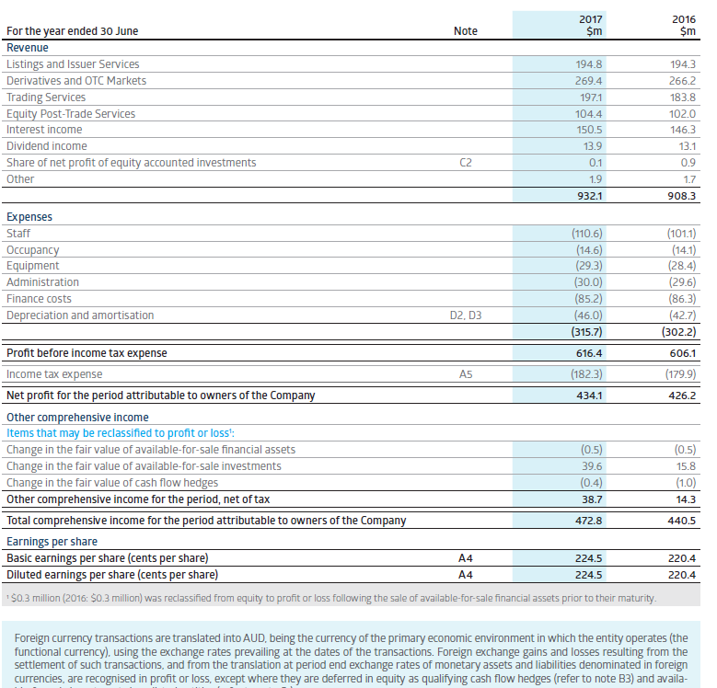
- Reverse repurchase agreements are recognised within cash and funds on deposit at the amount of the cash consideration paid. The securities purchased under the agreement are not recognised on the balance sheet as substantially all the risks and rewards of ownership are retained by the counterparty to the agreement.
- 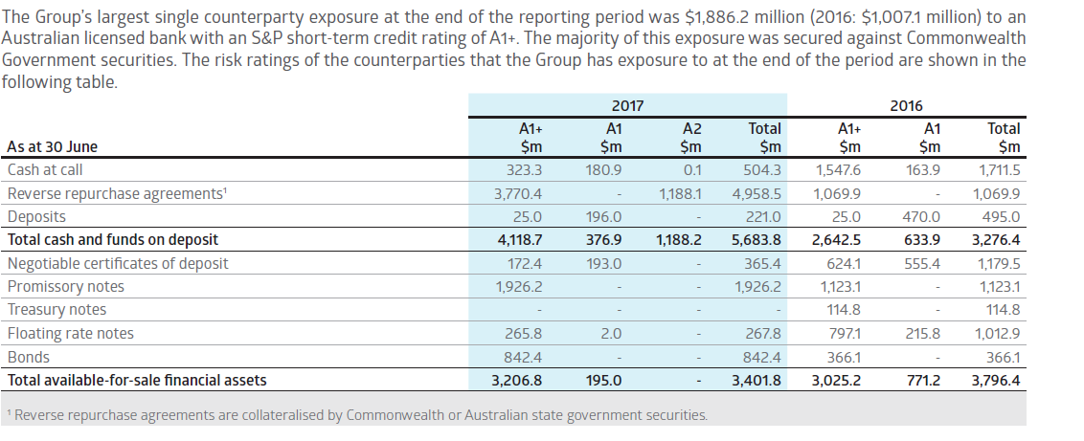
- 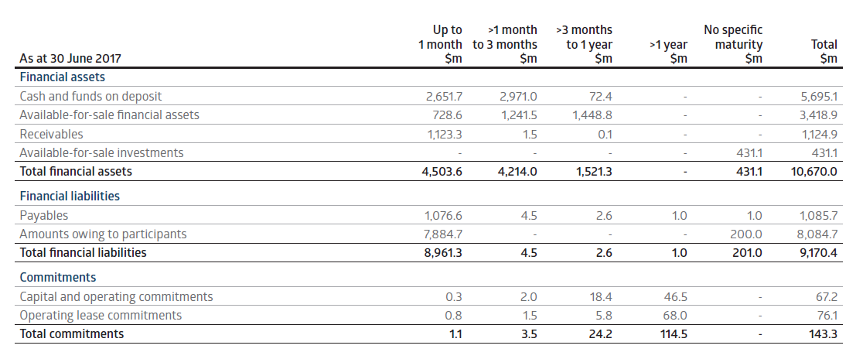
- 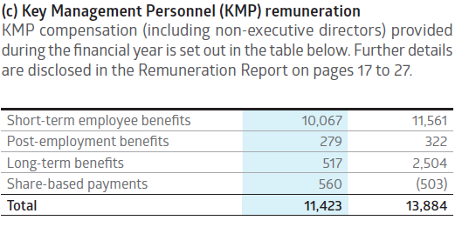
- (c) Contractual commitments and contingencies
- ASX has an agreement with ASX Clear for a $150.0 million (2016: $150.0 million) standby liquidity loan facility that may be used in limited and specific circumstances following the default of clearing participants.
- ASX has an agreement with CHESS Depositary Nominees Pty Limited (CDN) which provides $10.0 million (2016: $10.0 million) in funds to support CDN’s licence obligations if required. No payments were made under either facility in the current or prior financial year.
- 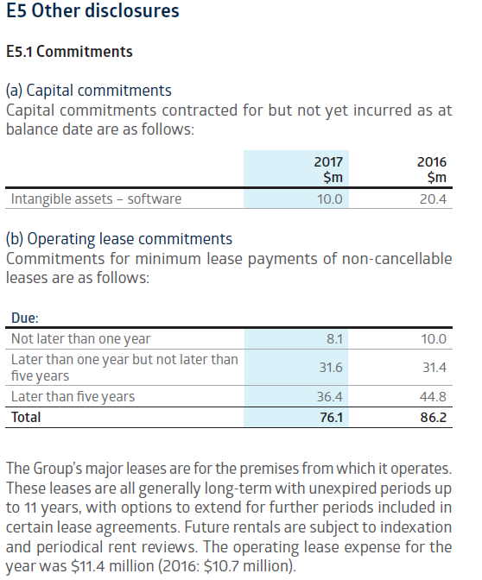
- 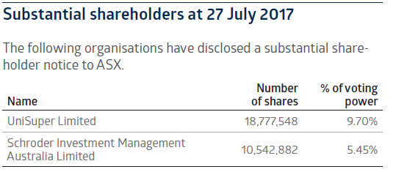
- 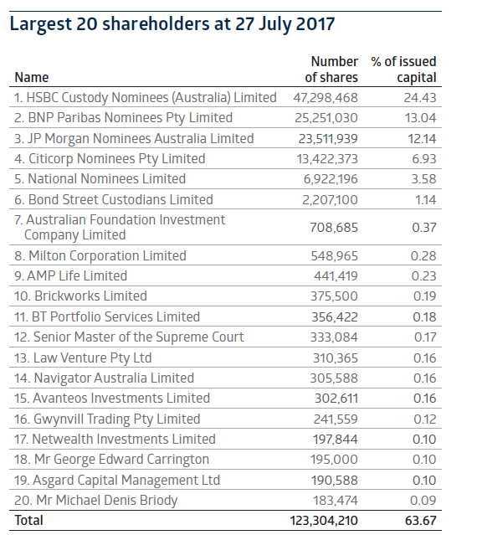
Risks
- Director fees
- The maximum aggregate amount that may be paid to all ASX non-executive directors in their capacity as members of the ASX Board and its committees, and as directors of subsidiary boards, is $2.8 million per annum. This was approved by shareholders at the 2012 AGM. The amount paid in FY17 was $2.4 million.
- ASX reviewed its non-executive director fee structure in August 2017 and made changes that will take effect in October 2017. These were determined having regard to changed responsibilities of directors across ASX's governance forums.
- At the 2017 AGM, ASX will seek shareholder approval to increase the maximum aggregate amount payable to directors from $2.8 million to $3.0 million. The proposed new maximum reflects the new fee structure and takes into account changes in the number and responsibilities of ASX's non-executive directors, while maintaining a fee buffer to provide flexibility. Additional information on this item of business at the AGM is included in the Notice of Meeting.
- The Board reviews its fees regularly in line with ASX’s objectives for non-executive remuneration.
- 