ASX Ltd – ASXFY Financial Notes
Started on 7/24/18
General Info
- 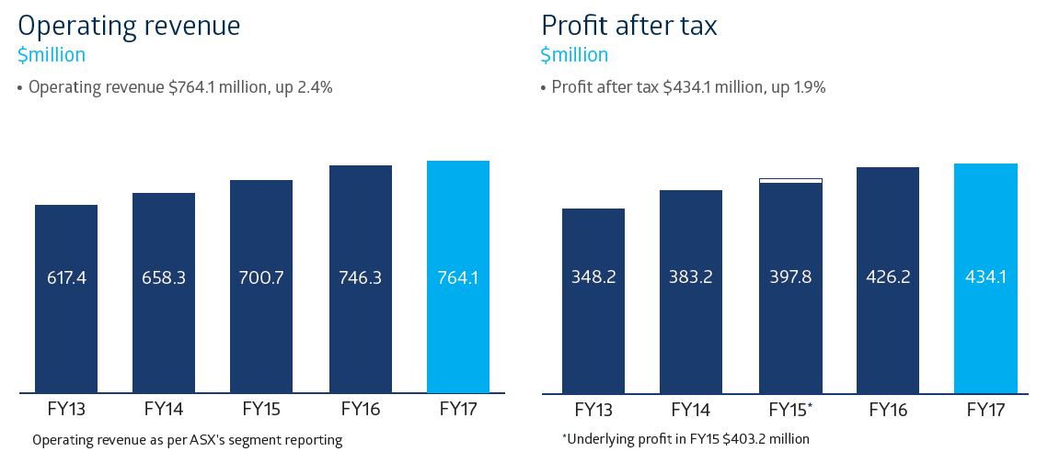
- 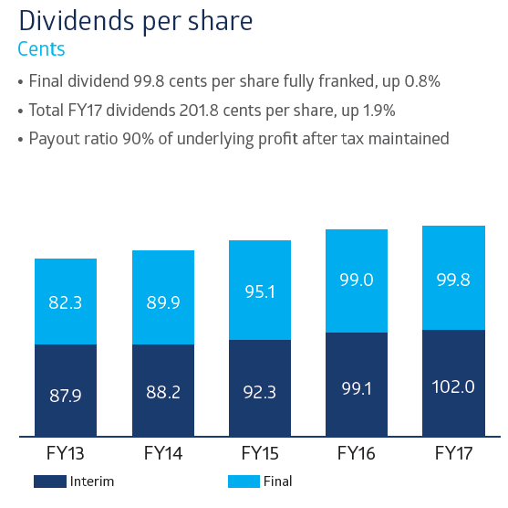
- We upgraded the trading platform for our largest business, raised the profile of ASX’s listings and clearing franchise internationally, and marked the 30th anniversary of ASX’s formation, when Australia’s six state-based stock exchanges merged to establish one national market.
- The benefits of the 1987 amalgamation still resonate, with ASX’s global scale, connectivity and reputation attracting increasing numbers of companies, traders and investors from home and abroad. It paved the way for ASX’s demutualisation and listing in 1998, and the merger with the Sydney Futures Exchange in 2006, which brought equities and futures together to create one of the world’s first multi-asset class, integrated exchange groups. The innovation we demonstrated three decades ago continues today as we seek better ways to service our customers and strengthen the resilience and competitiveness of Australia’s financial markets.
- ASX continued its solid financial performance in financial year 2017 (FY17), with revenue growth in most major areas of the business. The exception was the Listings and Issuer Services business, which was flat compared to FY16 and characterised by less capital raised but a greater number of new listings, the most in six years. ASX’s performance was driven by pockets of volatility in futures and equity markets, and strong progress on key initiatives such as Centre Point and OTC Clearing.
- ASX continues to invest in the infrastructure that positions Australia’s financial markets for the future. Expenses rose 6.0% to $180.9 million and capital expenditure was $50.3 million, both in line with market guidance. The spending relates to continued infrastructure upgrades as well as ASX initiatives such as the new futures trading system, development of the Bank Bill Swap (BBSW) platform and progress with distributed ledger technology (DLT) as a potential solution to replace CHESS
- ASX has been exploring DLT (commonly known as blockchain) as a possible replacement for CHESS. DLT has the potential to create a ‘single source of truth’ for all transactions that cannot be altered and which can be distributed to those who are permissioned to access it. We are developing an enterprise-grade DLT system with our partner Digital Asset Holdings. This will enable us to determine its suitability as a replacement for CHESS. We are on track to make an assessment on its suitability towards the end of this calendar year. ASX believes there is a real opportunity to simplify how our marketplace works and unlock a new era of efficiency and innovation. By working with our customers, we can develop the solution that best positions Australia’s market for the future.
- ASX clearing and settlement subsidiaries
- ASX has four subsidiary companies that hold CS licences to operate clearing and settlement facilities, and two intermediate holding companies. The CS boards focus on risk management and oversight of the operations of the CS subsidiaries.
- The responsibilities of these boards include the management of clearing and settlement risk, and compliance with the Financial Stability Standards determined by the Reserve Bank of Australia (RBA).
- The CS boards’ charter sets out further details regarding their functions and governance.
- ASX Clear and ASX Settlement are the sole providers of clearing and settlement arrangements for Australia’s cash equities market. The boards of ASX Clear and ASX Settlement are comprised of six directors. Each has three directors who do not sit on the ASX Limited Board. These three directors can form a quorum and do meet separately, constituted as the board of ASX Clear and ASX Settlement, to determine matters that require consideration of commercially sensitive information if another market operator or listing venue is obtaining services from, or access to, ASX’s CS facilities. These boards also oversee Management’s handling of commercially sensitive information, provision of services or access relating to other market operators and listing venues. ASX Limited directors do not attend or receive copies of papers or minutes for such meetings. Management attendance is limited to employees given permission by the relevant market operator or listing venue.
- Derivatives and OTC Markets
- In March 2017, ASX successfully implemented a new futures trading system, replacing the platform that had been in place, with periodic updates, since the late 1990s.
- The new system is contemporary and uses global standard protocols. It provides customers with richer functionality, improved performance and reduced development and maintenance costs. It also offers a new way of working with our customers, with functionality allowing ASX to diagnose and discuss issues proactively with customers. The smooth go-live was helped by the extensive development and industry-wide testing program undertaken by ASX in close collaboration with customers.

Things of Note
- ASX is privileged to operate in an environment underpinned by Australia’s strong macro-economic drivers. These include one of the world’s largest savings pools, highly regarded regulatory framework and more than 25 years of uninterrupted economic growth. Alongside this, Australia continues to have one of the world’s highest rates of share ownership, with the latest ASX Australian Investor Study (published in May 2017) showing that 37% of Australian adults, or 6.9 million people, hold investments that are available through a financial exchange.
- 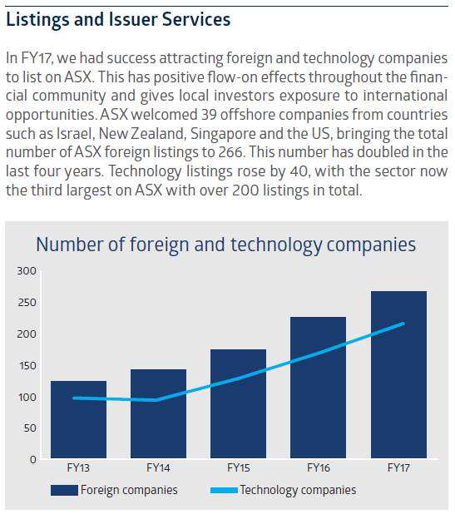
- ASX has developed a ‘sweet spot’ for listing companies in the $50-500 million market capitalisation range. The depth of our market’s liquidity, our contemporary rules and guidance, and the quality of our corporate governance standards are among ASX's advantages. The new admission criteria that ASX introduced in December 2016 have lifted the bar for entry to the ASX market, while maintaining a pathway for companies to list and access capital across their lifecycle.
- The expansion of ASX’s listings franchise in FY17 included growth in exchange-traded products (ETPs) such as ETFs – especially those offering international exposure, which now represent 42% of total ETP funds under management. ETPs have grown over the last five years from 84 products valued at $5.2 billion to more than 213 products valued at over $29.5 billion today.
- In FY17, ASX received regulatory approval to expand the range of investment products retail clients can apply for and redeem through the mFund Settlement Service. The mFund service provides faster and more convenient access to unlisted managed funds. The ability to offer a wider range of funds makes the service more attractive to brokers, advisers and their clients, including those in the growing SMSF sector. The level of funds under management within mFund doubled over the course of the year to more than $370 million.
- ASX also expanded the operating hours of our OTC Clearing business to clear interest rate swaps 24 hours a day. Value cleared in this service was up 88% in FY17 with a record $1,542 billion notional value cleared in the June quarter. We expect this to grow further when we roll out the service to clients of dealers (in addition to the existing dealer-to-dealer service) towards the end of 2017.
- Over the past five years, activity on ASX from offshore futures investors and traders has grown steadily. Global access to ASX markets has expanded in recent years via connections to financial hubs in Chicago, London, Singapore and Hong Kong. ASX’s overnight futures trading session, open from 5pm to 7am AEST, now accounts for 31% of all futures trading activity, up from 22% in FY12.
- 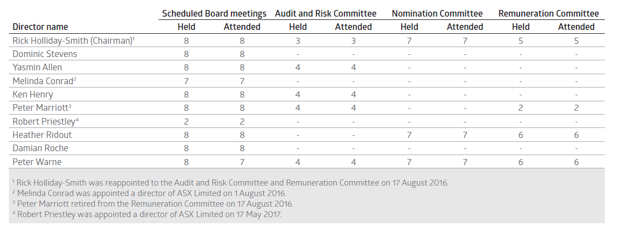
- Director shareholding policy and remuneration
- Board policy is that non-executive directors should accumulate at least 5,000 ASX shares (12,000 for the Chairman) within three years of their appointment. All directors with a tenure of more than three years meet this guideline. Directors with less than three years tenure are progressing towards achieving this guideline.
- Trading by ASX Group directors and employees
- ASX’s Group Dealing Rules restrict dealing in securities by ASX directors and employees. These were reviewed in FY17. Derivatives and hedging arrangements for unvested ASX securities, or vested ASX securities subject to holding locks, are prohibited.
- Payments to political parties
- ASX actively engages with government and political decision-makers about its role, the investments it is making to build world-class infrastructure, and the dynamic and globally competitive market environment in which it operates.
- ASX has a responsibility to Australia’s financial markets and its shareholders, customers and staff to articulate the opportunities and challenges facing its business, communicate its position on relevant public policy issues, and contribute to well-informed decision-making by government.
- During FY17, ASX paid $100,000 in membership fees to each of the Liberal Party Australian Business Network and the Federal Labor Business Forum. ASX’s membership of these business networks provides an opportunity to engage with a wide cross-section of policy and business decision-makers. No other payments to political parties were made during FY17.
- Environment, social and governance
- 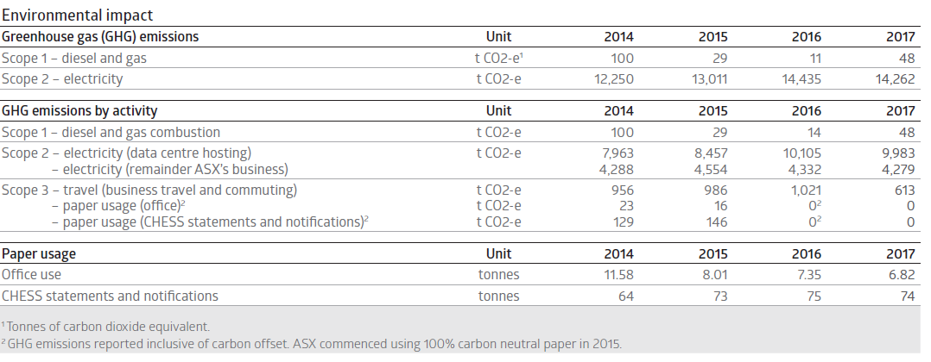
Risks

