King Digital Notes From Financials and Presentations
My notes are bolded and highlighted. Everything else is taken right from King’s most recent financials.
General Info
We were originally incorporated in September 2002 as Midasplayer.com Limited, a company organized under the laws of England and Wales. In December 2006, we established Midasplayer International Holding Company Limited, a limited liability company organized under the laws of Malta, which became the holding company of Midasplayer.com Limited and our other wholly-owned subsidiaries. The status of Midasplayer International Holding Company Limited changed to a public limited liability company in November 2013 and its name changed at that time to Midasplayer International Holding Company p.l.c. On March 25, 2014 and in connection with our IPO, King Digital Entertainment plc, a company incorporated under the laws of Ireland, became our holding company by way of a share-for-share exchange in which the shareholders of Midasplayer International Holding Company p.l.c. exchanged their shares in Midasplayer International Holding Company p.l.c. for shares having substantially the same rights in King Digital Entertainment plc. We completed our IPO in March 2014.
We are a leading interactive entertainment company for the mobile world. As of fourth quarter 2014, we had 533 million average monthly active users playing our games in over 200 countries and regions. In the same period, we had three of the top ten grossing games on Apple’s App Store and four of the top ten grossing games on the Google Play Store in the United States, our largest market. Since launching our first game in 2003, we have gained deep experience in game design and have built a massive network of loyal players. We believe that our high quality, innovative games are at the heart of our success. Our leading games include Candy Crush Saga, Candy Crush Soda Saga, Farm Heroes Saga, Pet Rescue Saga and Bubble Witch 2 Saga. Our approach has allowed us to build a strong network allowing for rapid adoption of new games. Within a week of its mobile launch, Candy Crush Soda Saga became a top 10 grossing game worldwide, faster than any other King game, which demonstrates the power of our network and our franchise brands. In fourth quarter 2014, an average of 149 million daily active users played our games more than 1.5 billion times per day.
We believe we are well positioned to take advantage of the significant opportunity in the digital games industry. Casual games have broad appeal, and represent the biggest category in mobile games in terms of monthly active users. We have become a leader in mobile games through our focus on the casual genre, our commitment to growing and maintaining our player network and our ability to generate revenue from our games. We believe we can capitalize on our success by further broadening our appeal. To do this, we are evolving our current casual games with innovative enhancements beyond their core mechanics, widening our portfolio with new games in different and adjacent genres and attracting new players while nurturing our existing player base.

Our 2014 plan was focused on diversifying gross bookings, scaling our game development capacity, building our corporate infrastructure, while maintaining profitability. We achieved the following in 2014:

 | • |  | We launched five games on mobile platforms and three on Facebook, including our first franchise sister title, Candy Crush Soda Saga, and first sequel,Bubble Witch 2 Saga;

 | • |  | Of the five games we launched on mobile in 2014, four reached the top 15 grossing games in the United States, our largest market;

 | • |  | We grew our non-Candy Crush Saga gross bookings from 22% of our total gross bookings in the fourth quarter of 2013 to 55% in the fourth quarter of 2014¹;

 | • |  | We generated over $574 million in profit, $661 million in net cash generated from operating activities, $950 million in Adjusted EBITDA, and had an adjusted EBITDA margin of 42%²;

 | • |  | We expanded our game development resources from six to nine game development studios, accessing talent in six countries spanning two continents;

 | • |  | We grew to approximately 1,200 employees at December 31, 2014 from approximately 660 employees at December 31, 2013; and

 | • |  | We completed two technology-driven acquisitions, adding a new game engine and dynamic social CRM platform to our technology stack. We also completed a game studio acquisition expanding our talent pool and establishing a presence in Asia.

Financial Notes
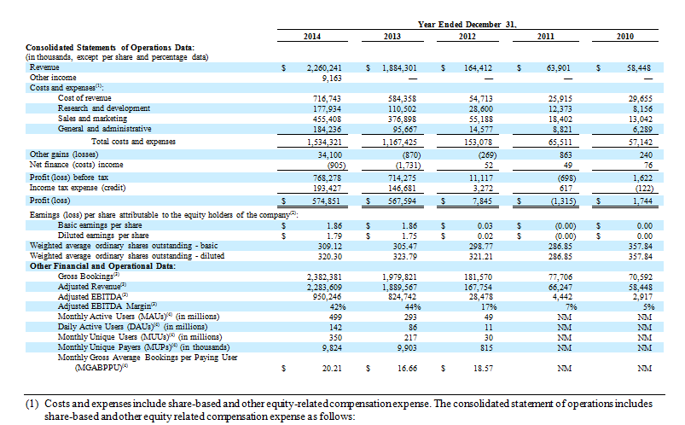
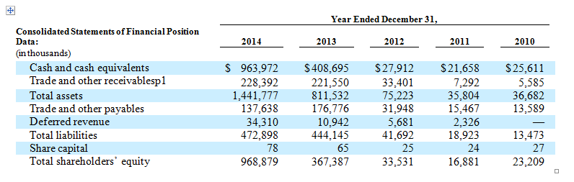
A LOT OF USE OF NON GAAP METRICS LIKE GROSS BOOKINGS, ADJUSTED REVENUE, AND EDJUSTED EBITDA.
Charlie Munger, Warren Buffett, and other prominent value investors call metrics like these, especially EBITDA, bullshit earnings. And for good reason.
When companies use metrics like this its with the companies own formulas that make their margins looks better than in normal cases.
I know “new” tech companies have to use some of these new metrics. But this is excessive.
In the fourth quarter of 2014, our top three games Candy Crush Saga, Farm Heroes Saga and Candy Crush Soda Saga accounted for 77% of our total gross bookings (across the web and mobile channels in the aggregate). Candy Crush Saga, accounted for 45% of our total gross bookings in the fourth quarter of 2014 (across the web and mobile channels in the aggregate). In the future, the gross bookings from our other games, including our newer games, may not be sufficient to offset any decline in the gross bookings of Candy Crush Saga. If the gross bookings of our top games, including Candy Crush Saga, are lower than anticipated and we are unable to broaden our portfolio of games or increase gross bookings from those games, we will not be able to maintain or grow our gross bookings and our financial results will be adversely affected.

Our continued growth will depend on our ability to regularly develop new games, expand our franchises and enhance our existing games in ways that improve the gaming experience for both paying and non-paying players while encouraging the purchase of virtual items within our games. In the event our traditional game development model ceases to be effective or we adopt new game development models that fail to be as successful or that new games do not generate a sufficient amount of gross bookings, our current development costs would increase and our operating results would suffer. It is possible that only a small number of our games, if any, become successful and generate significant purchases of virtual items.
We have experienced a period of significant rapid growth and expansion in our operations that has placed, and continues to place, significant strain on our management and resources. For example, our staff headcount and the scope and complexity of our business have increased significantly, with the number of employees increasing from approximately 660 as of December 31, 2013 to approximately 1,200 as of December 31, 2014, and the number of game studios reaching a total of nine in 2014, with eight game studios in Europe and one game studio in Asia to support our growth and game development. We expect headcount growth to continue for the foreseeable future.
We face significant competition, there are low barriers to entry in the digital gaming industry, and competition is intense.
If we are able to develop new games that achieve success, it is possible that these games could divert players of our other games without growing the overall size of our network, which could harm our operating results.
One of our key operating principles is that the player comes first, which we believe is essential to our success in increasing our growth and engagement and in serving the best, long-term interests of the company and our shareholders. Therefore, we may forgo certain expansion or short-term revenue opportunities that we do not believe will enhance the experience of our players, even if our decision negatively impacts our operating results in the short term. It is possible that our decisions may not result in the long-term benefits that we expect, in which case our business and operating results could be harmed.
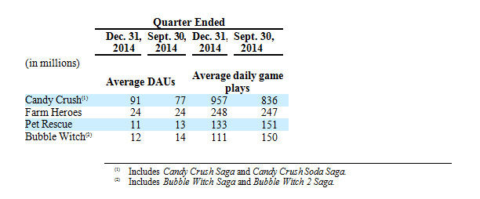
Our most successful game, Candy Crush Saga, accounted for 45% of our gross bookings in the quarter ended December 31, 2014 compared to 51% in the quarter ended September 30, 2014 and 78% in the quarter ended December 31, 2013. We believe Candy Crush Saga will continue to represent a lower proportion of our gross bookings as we continue to diversify our game portfolio.
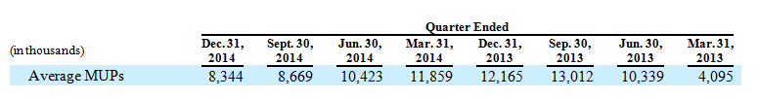
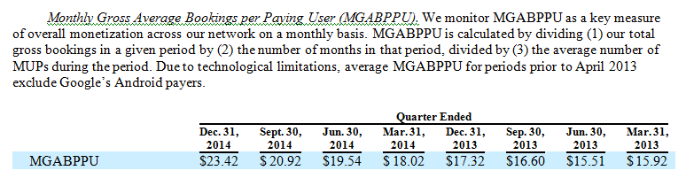
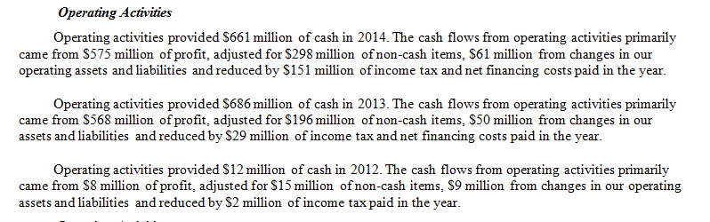
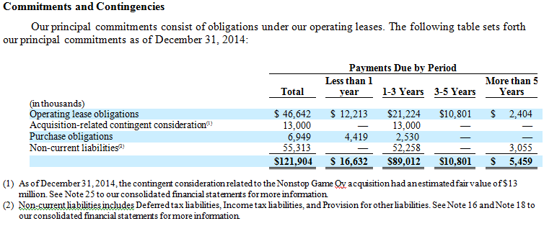
Dividends and Other Payments
On January 31, 2014, our board of directors declared a dividend of $0.795 per share with respect to our equity securities that are eligible to receive dividends, amounting to a total dividend of $217 million in aggregate, which was paid on February 6, 2014.
In April 2014, we paid $29 million to employees who held our discretionary bonus units, which represents 50% of the aggregate amounts payable under these incentive arrangements. We also paid an additional $9 million in related social security charges. The remaining 50% will be payable in the first quarter of 2015, provided such employees are still employed by us at that time.
In August 2014, our board of directors approved a special dividend of $0.46 per share with respect to our equity securities that are eligible to receive dividends, amounting to a total dividend of $147 million in aggregate to be payable to shareholders of record on September 30, 2014. The dividend was paid on October 22, 2014.
On February 12, 2015, our board of directors declared a special dividend of $0.94 per share with respect to our equity securities that are eligible to receive dividends, amounting to a total dividend of approximately $300 million in aggregate, to be payable to shareholders of record on March 4, 2015. We expect the dividend to be paid on March 24, 2015.
Certain of our equity securities and other share-based incentive awards are not eligible to receive dividends. As a result, on October 21, 2013 and January 31, 2014, our board of directors approved aggregate special cash grants of $28 million and $31 million, respectively, to our current personnel and directors that hold such securities and awards. These special grants, along with $12 million in related social security charges, are recognized in the consolidated statement of operations over the vesting period of the underlying equity securities or awards.
Share Repurchase Program
On November 4, 2014, our board of directors approved (subject to requisite regulatory and shareholder approval) a share repurchase program of up to $150 million worth of our ordinary shares to be effected through open market purchases. We obtained the requisite approvals for the program from shareholders and the Irish Takeover Panel on January 29, 2015. The board of directors approved a one-year extension of the share repurchase program and determined that it would seek a renewal of the requisite approvals from the Irish Takeover Panel and shareholders at the next annual general meeting in mid-2015.
No repurchases of shares were made under this program in the year ended December 31, 2014. Between January 29, 2015 and February 11, 2015, we repurchased an aggregate of 745,997 shares for $10 million under this program.
The aggregate compensation to our executive directors, executive officers and key management personnel, a total of ten individuals, for the year ended December 31, 2014 was $105.3 million, which includes $78.0 million of share-based payments, as well as pension, health insurance and life insurance benefits. Two key management personnel included in this group were key management personnel of Midasplayer International Holding Company p.l.c., the predecessor to King Digital Entertainment plc, and ceased to be key management personnel upon our IPO. Our executive directors, executive officers and key management personnel will also be paid an aggregate of $12.2 million including the remainder of special cash grants awarded in 2013, 2014 and a new grant awarded in 2015.
Our compensation committee may, without shareholder approval, reprice our share options or stock appreciation rights and, provided the repricing is a reduction in the exercise price, the consent of the participant will not be required. Also, with the consent of the participant, our compensation committee may pay cash or grant new awards in exchange for the surrender and cancellation of outstanding awards.
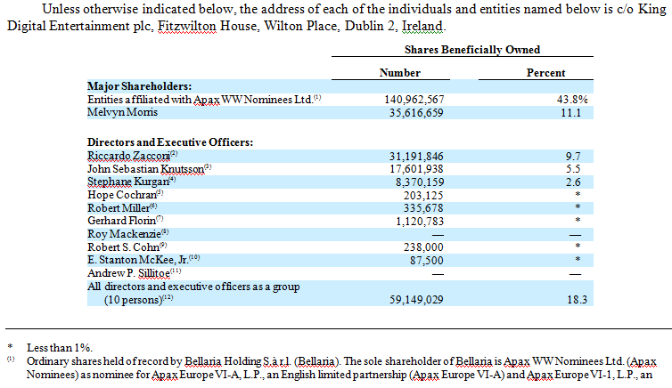
Registration Rights Agreement
On March 25, 2014, Riccardo Zacconi, John Sebastian Knutsson, Patrik Stymne, Lars Markgren, Thomas Hartwig, Melvyn Morris, Stephane Kurgan, a trust associated with Stephane Kurgan, entities associated with Apax Nominees and Index Ventures, and the Company entered into a Registration Rights Agreement (Registration Rights Agreement). The Registration Rights Agreement contains customary registration rights, including:
Demand Registration Rights. Certain of such holders have the right to request that we register their shares for sale, subject to customary underwriter’s cutbacks. These holders are entitled to a specified number of demand registration rights six months following our IPO. Those holders that do not have demand registration rights will be entitled to include their shares in any such registrations once a demand request is made.
Shelf Registration Rights. After we are eligible to use a “shelf” registration statement, certain of such holders shall have the right to request that we file a shelf registration statement. We will not, however, obligated to file a shelf registration statement if we have already effected a specified number of shelf registrations or if a shelf registration statement is not available for such offering by holders wishing to participate. Those holders that do not have shelf registration rights will be entitled to include their shares in any such registrations once a shelf request is made.

Piggyback Registration Rights. If we propose to file a registration statement for a public offering of our securities, then we must offer the parties to this agreement an opportunity to include in such registration all or part of their shares, subject to customary underwriter’s cutbacks. Such holders shall have first priority to sell in any such offering (other than the shares we sell) over the shares of any other holders.
Expenses of Registration. We will pay specified expenses related to any demand, piggyback or shelf registration pursuant to the Registration Rights Agreement other than underwriting commissions and discounts.
Indemnification. We will have certain indemnification obligations in connection with the registration rights under the Registration Rights Agreement.
Repurchase of Shares
On January 31, 2014, we repurchased 17,227,880 ordinary shares held by Stephane Kurgan, our Chief Operating Officer and a member of our board of directors, in exchange for an aggregate repurchase price of $1,240,407 plus 7,422,180 Linked Options with an exercise price of $31.37 per share with Linked Shares. Mr. Kurgan subsequently subscribed for 4,190,580 of such Linked Shares for an aggregate subscription price of $536,394. The terms of the repurchase and issuance were determined through arms-length negotiations among the parties. The remaining proceeds from the repurchase of the ordinary shares were used to subscribe for other restricted shares linked to a previous grant of share options.
Loan Agreements
On June 14, 2013, we entered into a loan facility agreement with Mr. Kurgan. Pursuant to the loan facility, we loaned Mr. Kurgan £600,000, with an initial interest rate of 4% per year, to fund Mr. Kurgan’s purchase of a property. The aggregate principal and interest accrued under such loan was repaid in full on October 28, 2013. The terms of this loan facility were determined through arms-length negotiations among the parties.
Service Agreements
In 2011, 2013, and 2014 Midasplayer AB entered into various agreements with Joshsthlm AB, an entity affiliated with John Sebastian Knutsson, our Chief Creative Officer and a member of our board of directors, pursuant to which we received, or continue to receive, certain developer, project management and design consulting services and a software license. Joshsthlm received $367,000, $838,000 and $1,633,000 for these services in 2012, 2013 and 2014, respectively. The 2014 agreement superseded the 2011 and 2013 agreements. The 2014 agreement includes a $1.6 million commitment by King with respect to services in 2015.
In May 2013, we entered into a management services arrangement with Apax Partners LLP, an advisor to our largest shareholders and an entity affiliated with Roy Mackenzie and Andrew Sillitoe, members of our board of directors, pursuant to which we paid £3,000 per day for certain management services. This arrangement concluded on November 30, 2013. The terms of this arrangement were determined through arms-length negotiations among the parties.
Equity Awards
Since January 1, 2012, we have issued an aggregate of 10,765,580 ordinary shares and share options exercisable for 16,398,430 ordinary shares to our directors and executive officers. The weighted-average purchase price for the ordinary share issuances was $0.22 and the weighted-average exercise price per share for the share option issuances was $18.08.
Authorized Share Capital
As of December 31, 2014, our authorized share capital was $81,000 and €40,000 divided into 1,000,000,000 ordinary shares with a nominal value of $0.00008 per share, 40,000 Euro Deferred Shares with a nominal value of €1.00 ($1.30) per share, and 12,500,000 preferred shares with a nominal value of $0.00008 per share (Undesignated Shares).

Issued Share Capital
As of December 31, 2014, our issued share capital was $25,758 and €40,000 divided into 321,958,914 ordinary shares with a nominal value of $0.00008 per share and 40,000 Euro Deferred Shares with a nominal value of €1.00 ($1.30) per share.
Share Options
As of December 31, 2014, we had outstanding options to acquire 22,879,801 ordinary shares which were granted to employees, directors and consultants (i) before the date of our IPO in exchange for equivalent options granted by Midasplayer International Holding Company p.l.c. pursuant to individual share option agreements and (ii) following our IPO, pursuant to our 2014 Plan. The options have a weighted-average exercise price of $14.72 per share and generally expire ten years after their grant (or in the case of options granted before the date of our IPO, on the tenth anniversary of the original issuance of the options to purchase shares in Midasplayer Holding Company p.l.c.).
Restricted Share Units
As of December 31, 2014, we also had outstanding 1,799,515 RSUs, which were granted to employees, directors and consultants pursuant to our 2014 Plan since the date of our IPO. Upon vesting of each RSU, an ordinary share is issued to the holder subject to payment of the nominal value of $0.00008 per share. Participants in our 2014 Plan are generally required to pay one U.S. Dollar, or a unit of their local currency, in consideration for the grant of an option or an award of RSUs.
Share Options with Linked Shares
In January 2014, pursuant to individual option agreements, we granted “D1” options to purchase our ordinary shares (Linked Options) to certain employees and in connection with such Linked Option grants, the optionholder also was entitled to subscribe for an equivalent number of “D3” ordinary shares at the fair market value for such ordinary share. Immediately prior to our IPO, the D3 ordinary shares converted into our ordinary shares, subject to contractual restrictions with respect to transfer, voting and the right to dividends, to participate in any bonus issues of shares or to receive notice of, and vote at, general meetings (Linked Shares). This linking of an option to subscribe for ordinary shares with an equivalent number of Linked Shares is intended to allow for a more favorable tax treatment of the holder’s gains upon a sale of our ordinary shares and not to otherwise provide additional economic value in addition to the value delivered by the option over ordinary shares. The terms of the Linked Options substantially mirror the provisions of the other outstanding share options described in “Share Options” above.
Of the outstanding options to acquire 22,879,801 ordinary shares as of December 31, 2014 referenced above, 13,999,650 are Linked Options, and of the 321,958,914 ordinary shares outstanding as of December 31, 2014, 2,535,097 are Linked Shares.
A portion of the Linked Options are subject to market-based vesting conditions based on our achievement of an average target price per share over a specified time period, which is either $25.54, $31.54 and $37.54. These Linked Options will vest in three tranches over seven years depending on our share price.
Upon exercise of vested Linked Options, the optionholder will either receive value through the “release” of Linked Shares or the exercise of the Linked Options, depending on the share value at the time of exercise. Each option agreement contains a formula to determine how many Linked Shares will be released from the Linked Share restrictions in order to deliver to the optionholder the in-the-money value of the Linked Option (i.e. market value of our ordinary shares less the exercise price). If the in-the-money value of the vested Linked Options is delivered by the release of Linked Shares, we will cancel the corresponding number of Linked Options. To the extent the optionholder does not hold a sufficient number of Linked Shares to deliver the in-the-money value of the Linked Options being exercised, then the Linked Option will be exercised with respect to ordinary shares. For more information about these Linked Options and Linked Shares, reference is made to our final prospectus filed on March 27, 2014 pursuant to Rule 424(b) under the Securities Act relating to the Registration Statement on Form F-1, as amended (File No. 333-193984).
If an optionholder holds Linked Shares that are unreleased and leaves the company, the unreleased Linked Shares may be acquired by an employee benefit trust set up by us, generally for the lesser of (1) the price paid for such Linked Shares or (2) the market value of such Linked Shares less 25%. We may also at any time require the executive to transfer such shares that are no longer capable of being released to an employee benefit trust. Generally, in such events, the price payable will be the lesser of (1) the price paid for such Linked Shares and (2) the market value of such Linked Shares less 25%. If an optionholder’s employment is terminated in connection with a sale of our company, 100% of the Linked Options will vest immediately prior to the sale.
General
None of our shares are currently held in treasury. All of our ordinary shares issued and outstanding are registered shares and not bearer shares, and are fully paid, duly authorized and validly issued.
We have the authority, pursuant to our Articles, to increase our authorized but unissued share capital by ordinary resolution by creating additional shares of any class or series. An ordinary resolution of our company requires more than 50% of the votes cast at a shareholders’ meeting by the shareholders entitled to vote at that meeting.
As a matter of Irish law, the board of directors of a company may issue authorized but unissued new shares without shareholder approval once authorized to do so by its articles of association or by an ordinary resolution adopted by the shareholders at a general meeting. The authority conferred can be granted for a maximum period of five years, at which point it must be renewed by the shareholders by an ordinary resolution. Because of this provision of Irish law, our Articles authorize our board of directors to issue new shares up to the amount of our authorized but unissued share capital without shareholder approval for a period of five years from the date our Articles are adopted. We expect that we will seek to renew such general authority at an annual general meeting before the end of that five-year period.
Our Articles also authorize our board of directors, without shareholder approval, to determine the terms of the Undesignated Shares issued by us. Our board of directors is authorized, without obtaining any shareholder vote or consent, to provide from time to time for the issuance of ordinary shares or other classes or series of shares and to establish the characteristics of each such other class or series, including the number of shares and their preference or deferred or other special rights and privileges or limitations, conditions and restrictions, whether in regard to dividend, voting, return of capital, conversion, redemption or otherwise.
Except as otherwise described in this section or as prescribed by law, there are no limitations on the rights to own, or exercise voting rights with respect to, our ordinary shares.
Irish law does not recognize fractional shares held of record. Accordingly, our Articles do not provide for the issuance of fractional shares and our share register will not reflect any fractional shares. Even if an issuance, alteration, reorganization, consolidation, division, or subdivision of our shares would result in a shareholder being entitled to fractional shares, no such fractional shares will be issued or delivered. All such fractional shares may be sold for the best price reasonably obtainable and the aggregate proceeds from such sale will be distributed on a pro rata basis, rounding down to the nearest cent, to each shareholder who would otherwise have been entitled to receive fractional shares.
Directors’ Borrowing Powers
The directors may exercise all the powers of our company to borrow or raise money and to mortgage or charge its undertaking, property, assets and uncalled capital or any part thereof, and subject to the Irish Companies Acts to issue debentures, debenture stock and other securities whether outright or as collateral security for any debt, liability or obligation of ours or of any third party, without any limitation as to amount.
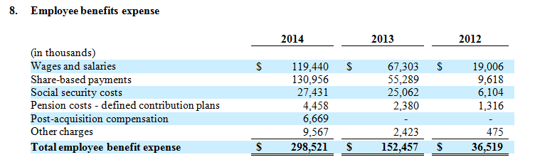
A deferred tax liability of $35,376,000 has not been recognized in respect of timing differences with regard to the undistributed profits in foreign subsidiaries of the Company of $512,302,000 (2013: $354,304,000). The Company has control over the reversal of these timing differences and does not intend to repatriate cash to KDE, our ultimate parent in the form of a dividend.
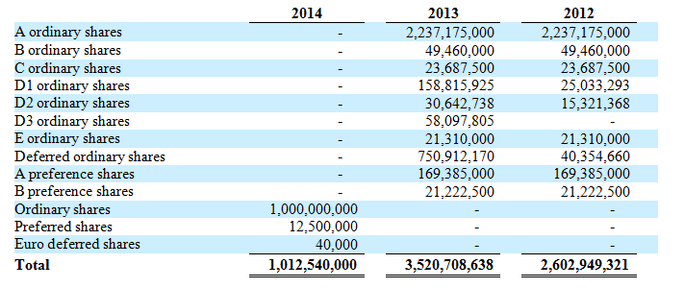
22. | Related party transactions
All companies forming part of the Group are considered to be related parties as these companies are ultimately owned by KDE. The Group’s largest shareholder is Bellaria Holding S.a.r.l, for whom Apax WW Nominees Ltd. is the sole shareholder, and advised by Apax Partners, a private equity firm affiliated with Roy Mackenzie and Andrew Sillitoe, members of the Board. The remaining shares are widely held.
The following transactions were carried out with related parties:

 | (a) | Key management personnel remuneration
Key management personnel compensation for employee and director services during the year is shown below:

 |  | 2014 |  |  |  | 2013 |  |  |  | 2012
(in thousands)
Short-term employee benefits |  | $ | 28,996 |  |  | $ | 20,754 |  |  | $ | 1,387
Share-based payments ⁽¹⁾ |  |  | 79,476 |  |  |  | 9,393 |  |  |  | 701
Post-employment benefits |  |  | 254 |  |  |  | 116 |  |  |  | 112
Total |  | $ | 108,726 |  |  | $ | 30,263 |  |  | $ | 2,200

 | ⁽¹⁾ | Non-cash amount. Expense recognized in the statement of operations

